**SCD Type 2 Implementation:**

In SCD Type 2 we maintain the history and also append the new records. If the same records exist in the existing table before then we make the existing similar records inactive and append the new similar records to them as active status. In case of new records, we simply insert them into existing data.

Like in the below example we have 102 and 103 emp Id in the new records which are also present in the existing record then we make their status 0 to show that they are history records and append the new records to the existing table.

Existing Data

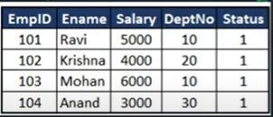

Incoming data

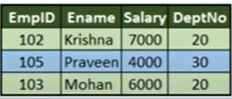

After insertion of new records

